x =linspace(0,2\*pi,100);

y = cos(x);

plot(x,y);

xlabel('X-axis Label');

ylabel('Y-axis Label');

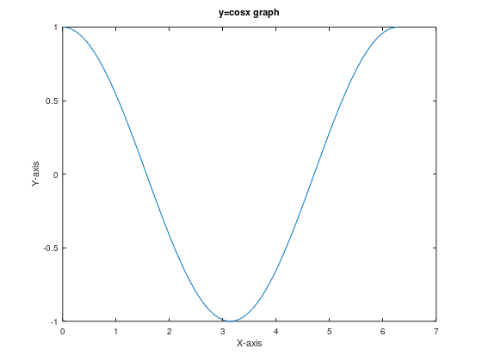

x =linspace(-2,2,100);

y = x.^2;

plot(x,y);

xlabel('X-axis');

ylabel('Y-axis');

title('y=x^2 graph');

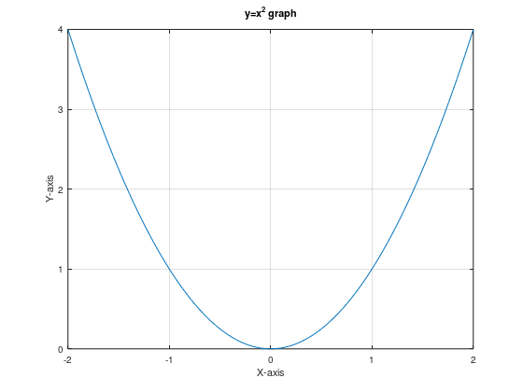grid on ;

x =linspace(-2,2,100);

y = x.^2;

plot(x,y);

xlabel('X-axis');

ylabel('Y-axis');

title('y=x^2 graph');

grid on;

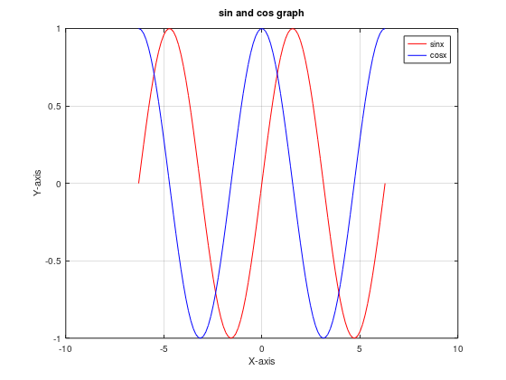

x =linspace(-pi,pi,100);

y =x;

f=sin(x);

plot(x,f,'r',x,y,'b');

legend('sinx','x')

xlabel('X-axis');

ylabel('Y-axis');

title('sinx and x graph');

grid on;

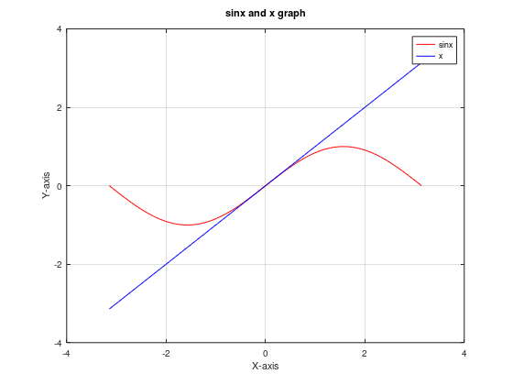

t=linspace(0,2\*pi,100);

x=cos(t);

y=sin(t);

plot(x,y);

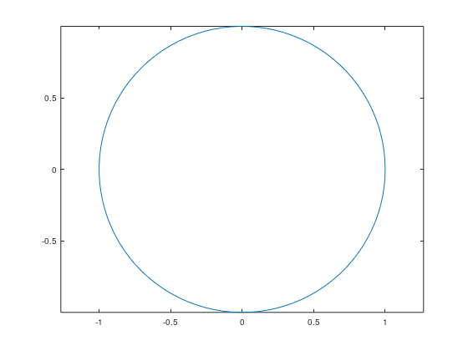axis equal;

x = linspace(-2, 2, 50); % 50 points from -2 to 2

y = linspace(-2, 2, 50);

% Create 2D grid

[X, Y] = meshgrid(x, y);

% Define function

Z = X.^2 + Y.^2;

% Plot surface

surf(X, Y, Z);

% Labels and title

xlabel('X-axis');

ylabel('Y-axis');

zlabel('Z-axis');

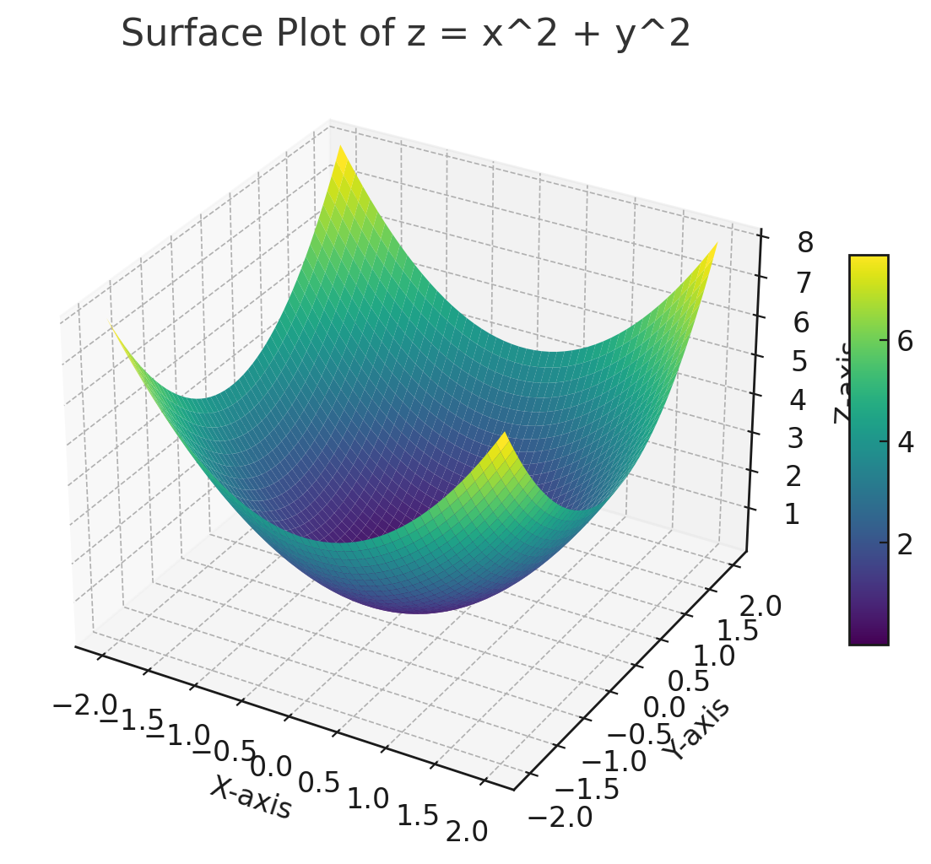title('Surface Plot of z = x^2 + y^2');

x = linspace(-2\*pi, 2\*pi, 200);

y1 = sin(x);

y2 = x;

y3 = x.^3 / 6;

plot(x, y1, 'r');

hold on;

plot(x, y2, 'b--');

plot(x, y3, 'g:');

hold off;

xlabel('X-axis');

ylabel('Y-axis');

title('Comparison of y = sin(x), y = x, and y = x^3/6');

legend('y = sin(x)', 'y = x', 'y = x^3 / 6', 'location', 'northwest');

grid on;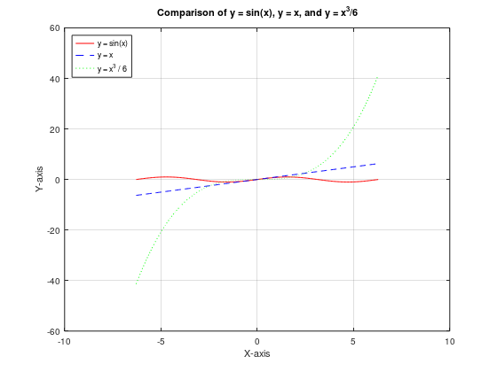

x = linspace(-2, 2, 100);

y = linspace(-2, 2, 100);

[X, Y] = meshgrid(x, y);

Z = X.^2 - Y.^2;

contour(X, Y, Z);

xlabel('x');

ylabel('y');

title('Contour Plot of z = x^2 - y^2');

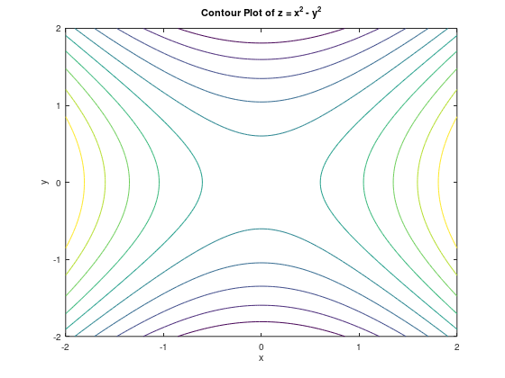

x = linspace(-2, 2, 100);

y = linspace(-2, 2, 100);

[X, Y] = meshgrid(x, y);

Z = X.^2 + Y.^2;

contour3(X, Y, Z);

xlabel('x');

ylabel('y');

zlabel('z');

title('3D Contour Plot of z = x^2 + y^2');

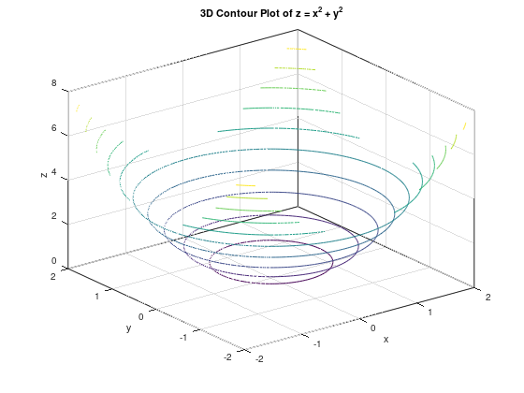

x = linspace(-pi, pi, 100);

y = linspace(-pi, pi, 100);

[X, Y] = meshgrid(x, y);

Z = sin(X) .\* cos(Y);

surf(X, Y, Z);

xlabel('x');

ylabel('y');

zlabel('z');

title('Surface Plot of z = sin(x)cos(y)');

view(45, 30);

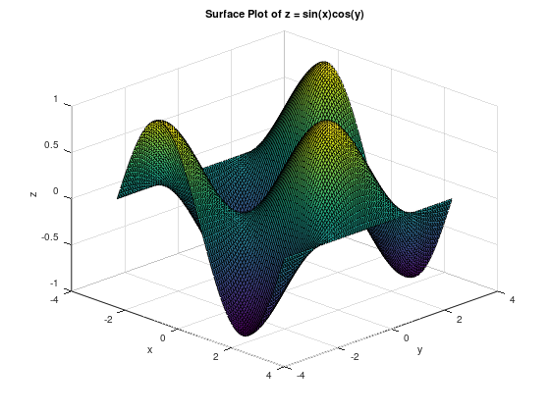

x = linspace(-2, 2, 100);

y = linspace(-2, 2, 100);

[X, Y] = meshgrid(x, y);

Z = exp(-X.^2 - Y.^2);

figure;

surf(X, Y, Z);

xlabel('x');

ylabel('y');

zlabel('z');

title('Surface Plot of z = e^{-x^2 - y^2}');

figure;

contour(X, Y, Z);

xlabel('x');

ylabel('y');

title('Contour Plot of z = e^{-x^2 - y^2}');

